**Puthiyathalaimurai Proudly Launches the 10th Edition of Its Prestigious Sakthi Awards**

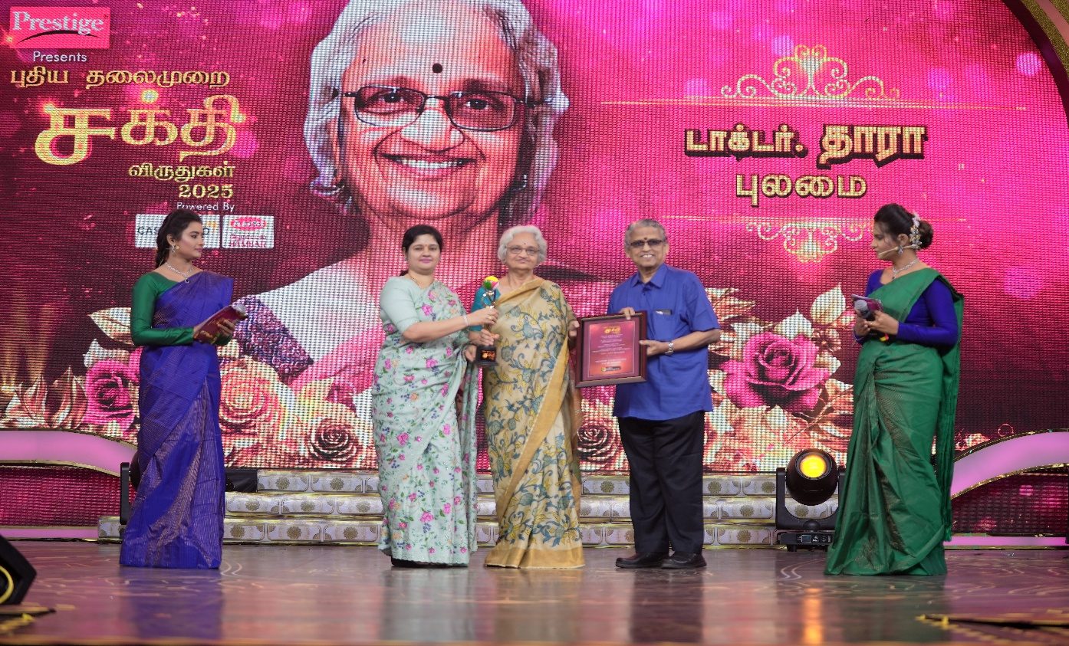

Chennai: Puthiyathalaimurai successfully launched the 10th edition of its prestigious Sakthi Awards, celebrating a decade of honoring women who have redefined boundaries and made remarkable contributions to society across diverse fields.

Presented annually, the Sakthi Awards recognize six extraordinary individuals who embody strength and inspire change. The awards are given in six distinct categories: Courage, Talent, Leadership, Knowledge, Compassion, and Achievement. The theme for the Sakthi Awards 2025 is “Accelerate Actions towards Achieving Gender Equality.”

**This year’s distinguished awardees include:**

**Courage Award:** Mrs. Muthamizh Selvi, the first woman from Tamil Nadu to conquer Mount Everest, inspiring countless others with her determination and grit.

**Talent Award:** Mrs. Purnaa Sundari I.R.S., a beacon of perseverance, who overcame visual impairment to serve as an officer in the Indian Revenue Service.

**Leadership Award:** Maj Gen Ignatius Delos Flora, who rose through the ranks in the military Nursing service to become the first Tamil Major General, breaking stereotypes with her exceptional service.

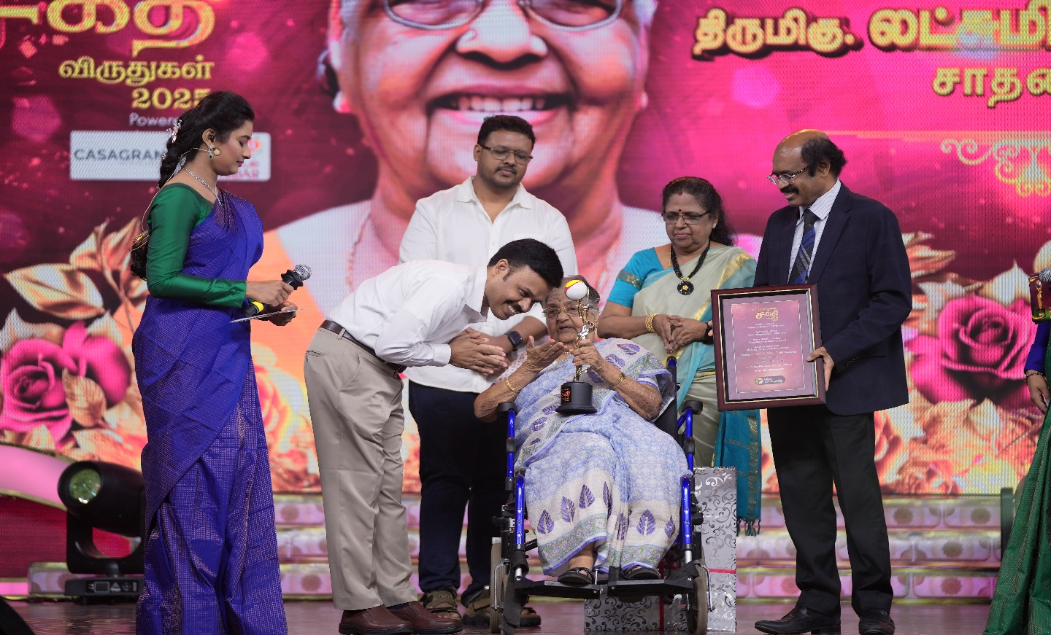

**Compassion Award**: Mrs. Shyamala Nataraj, recognized for her groundbreaking advocacy and policy work on HIV/AIDS awareness and rights.

**Knowledge Award:** Dr. Tara, honored for her tireless efforts to dispel superstitions surrounding mental illness and to promote mental health awareness in society.

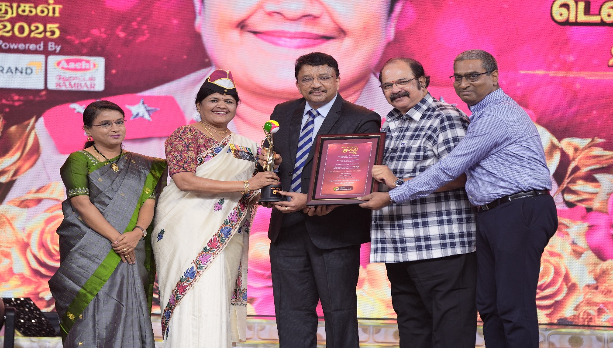

**Lifetime Achievement Award:** Captain Lakshmi Krishnan, 98 years old, she was actively involved in the Indian freedom struggle alongside Netaji Subhas Chandra Bose, beginning her journey of patriotism and courage at the young age of 15.

The vibrant awards ceremony took place recently at the Nandambakkam Trade Center in Chennai, attended by the public and several distinguished guests.

This grand celebration of women’s strength and resilience will be telecast on Puthiyathalaimurai Television on March 8, marking International Women’s Day.