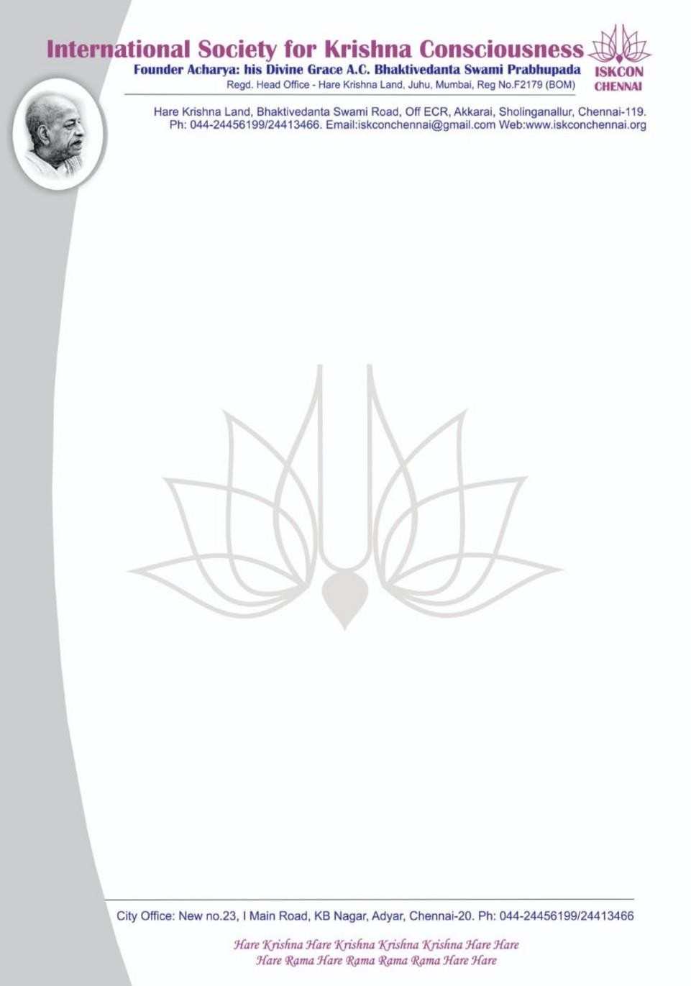

PRESS RELEASE 15 May 2024
SUBJECT : ISKCON CHENNAI Presents "Discover Yourself"
DATE : 20 May to 25 May 2024
Time: 8pm to 9pm.
Mode: Online (FREE CERTIFICATION COURSE)
Language: Telugu
International Society for Krishna Consciousness (ISKCON) Chennai conducts "Discover Yourself" - A journey of self discovery and empowerment in just 6 days through Online

"The two most important days in your life are the day you are born and the day you find out why" - Mark Twain

When we are born is past information, but to know why we are born will bring transformation. Learn the essence of life and Gita in six sessions of the "Discover Yourself" Course. This course will help clear your doubts on the spiritual path with transcendental knowledge thus offering peace and solace to the sincere practitioner.

Quench your thirst and enjoy this journey towards wisdom & bliss !! For more details contact through WhatsApp only @ +91 9848175279
We Request you to kindly publish the above matter in your esteemed Newspapers in for
the information and benefit of the readers. Thanking you,

Yours in Service,

Ranga Krishna Das

Temple Management Team, ISKCON Chennai

