Backstreet’s Back, Alright!
Iconic boy band Backstreet Boys bring blockbuster ‘DNA World Tour’ to India, returning to the country after 13 years

~ Brought to India by BookMyShow and Live Nation, the DNA World Tour celebrates 30 glorious years of the band’s electrifying music and makes a stop in India after five years of globe-trotting ~

~ BSB fans, look alive! Registrations for the Backstreet Boys: DNA World Tour – India are
NOW LIVE exclusively on BookMyShow ~

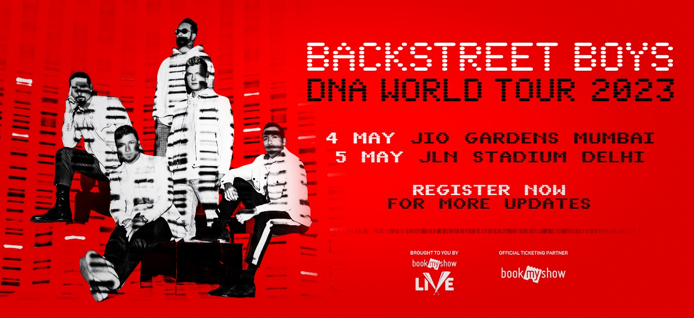
National, February 22, 2023: Everybody, Backstreet’s Back, Alright!

One of the best-selling bands of all time, the Backstreet Boys, have today announced that their blockbuster DNA World Tour will travel to India in May, 2023.

BookMyShow, India’s leading entertainment destination along with Live Nation is bringing the world-renowned Backstreet Boys: DNA World Tour to the country in a two-city tour, making a stop at the entertainment capital, Mumbai and the national capital, New Delhi. For the India leg, Backstreet Boys: DNA World Tour will play at Jio World Gardens, Mumbai on May 4th and Jawaharlal Nehru Stadium, New Delhi on May 5th 2023.

The iconic and legendary boy band that has won hearts of billions across three decades finally comes back to India after 13 years, answering the prayers of its massive fan-base in the country.

Celebrating 30 glorious years of a band that has continued to stay relevant in the music industry with a growing fanbase and an evergreen legacy that never goes out style, the DNA World Tour forays into the country after five years of travelling across the world to houseful shows and ecstatic audiences.

Registrations for the much-awaited ensemble coming to Mumbai and Delhi, India are now live exclusively on BookMyShow! Register now to get all details on ticket sales for the Backstreet Boys: DNA World Tour in India right here!

The Backstreet Boys: DNA World Tour, comes on the back of the boy-band favourite’s tenth studio album ‘DNA’ and is a production enigma when it comes to live music, transporting fans to a world that brings alive every fiber of love in every-body! In a marvelous performance in sync with pitch-perfect harmonies, matching outfits and killer dance moves, Backstreet Boys ensure that the crowd is always on their feet dancing like there’s no tomorrow, with hands up in the air swaying to their musical beats. Get ready for the male pop vocalists taking over the country with their dreamy personas, for when they set foot in the arena, the Backstreet Boys are in their absolute element, belting out a massive catalog of original hits to an outsized audience that screams back every word.

AJ McLean, Brian Littrell, Nick Carter, Howie Dorough and Kevin Richardson have been enthralling fans across the globe for over three decades and are expanding their massive world tour to India on popular demand. The DNA World Tour celebrates their rich history of flawless choreography, harmony-laden vocal prowess and an arsenal of mega-watt hits such as ‘I Want It That Way’, ‘Everybody (Backstreet’s Back)’ and ‘As Long As You Love Me’, along with the latest hits from their recent album ‘DNA’ including ‘Don't Go Breaking My Heart’, ‘Chances’ and ‘No Place’, amongst others.
The band also released the first episode of their new documentary series Making Of The DNA Tour, giving fans an inside look of the preparation for their highly-anticipated and massively successful world tour – watch it here! Additional episodes will be available on The Backstreet Boys YouTube channel.
DNA World Tour 2022 Schedule
May 1, 2023 | Zed East, Cairo, Egypt
May 4, 2023 | Jio World Gardens, Mumbai, India
May 5, 2023 | Jawaharlal Nehru Stadium, Delhi, India
May 7, 2023 | Etihad Arena, Abu Dhabi, UAE
May 9, 2023 | Al Dana Amphitheatre, Zallaq, Bahrain
May 11, 2023 | F1 Concert Cone - Jeddah Corniche Circuit, Jeddah, Saudi Arabia
May 13, 2023 | Live Park, Tel Aviv, Israel
May 16, 2023 | Grand Arena, Cape Town, South Africa
May 19, 2023 | SunBet Arena, Pretoria, South Africa

********

ABOUT BACKSTREET BOYS
For 29 years the Backstreet Boys have delivered the finest pop music one has to offer, making them one of pop’s most influential performers. With countless #1s, record-setting tours, numerous awards and worldwide sales in excess of 130 million, BSB has been recognized as the best-selling boy band in history.

In early 2019, BSB released their GRAMMY nominated 10th studio album “DNA” on RCA Records. The album debuted at #1 and features the Top 10 hit “Don’t Go Breaking My Heart.” The critically acclaimed and chart topping single was nominated for the “Pop Duo / Group Performance” 2019 GRAMMY, and was BSB’s first hit on the Billboard Hot 100 in 10 years. Upon its release, the single went straight to #1 on iTunes Top Songs and Global charts and charted in over 22 countries. In May 2019 the Backstreet Boys kicked off “The DNA World Tour” - the group’s biggest arena tour in 18 years thanks to the global success of their #1 new album. The DNA World Tour has seen the group sell out arenas all over North America, Europe, Asia and South America.

Over the years, the Backstreet Boys have continually captivated millions of people with their impressive catalogue of hit songs and creative partnerships.

ABOUT LIVE NATION ENTERTAINMENT
Live Nation Entertainment (NYSE: LYV) is the world’s leading live entertainment company comprised of global market leaders: Ticketmaster, Live Nation Concerts, and Live Nation Sponsorship. For additional information, visit www.livenationentertainment.com.

ABOUT BOOKMYSHOW
Launched in 2007, BookMyShow, owned and operated by Big Tree Entertainment Pvt Ltd (founded in 1999), is India's leading entertainment destination with global operations and the one-stop shop for every entertainment need. The firm is present in over 650 towns and cities in India and works with partners across the industry to provide unmatched entertainment experiences to millions of customers. Over the years, the company has evolved from a purely online ticketing platform for movies across 6,000 plus screens, to end-to-end management of live entertainment events including music concerts, live performances, theatricals, sports and more, all accomplished at par with global standards. Some of the key properties that BookMyShow has brought to its markets over the past few years include U2’s The Joshua Tree Tour, NBA’s debut games in India, Disney’s Aladdin, Cirque du Soleil BAZZAR as also international artists such as Coldplay, Ed Sheeran, Justin Bieber to name a few.

BookMyShow is invested in providing the best user experience, whether on-ground or online and to that effect, has developed the first-of-its-kind video streaming platform solely for live entertainment in India - ‘BookMyShow Online’, marking its entry in the streaming business. Complementing its cinemas business, the firm also launched ‘BookMyShow Stream’, India’s largest home-grown transactional video-on-demand (TVOD) platform hosting award-winning and critically acclaimed content from around the world. BookMyShow also houses India’s most extensive organic reviews and ratings engine for movies and has driven technology innovations, such as the m-ticket and Movie Mode, impacting tens of millions of users and the industry at large.

With continued support from marquee investors like TPG Growth, Stripes Group, Elevation Capital (formerly SAIF Partners), Accel and Network18, BookMyShow has constantly demonstrated category leadership, growing beyond India with operations in UAE, Singapore, Indonesia and Sri Lanka amongst others. The Mumbai-headquartered company counts Ticket Green, Eventifier, Masti Tickets and Townscript amongst its key investments in the sector. BookMyShow is also committed to society at large, by way of its charity initiative BookASmile, which supports special causes to enrich the lives of the less fortunate across India through entertainment-led experiences.

MEDIA CONTACTS:
BookMyShow: media@bookmyshow.com

